Performance Bottlenecks - Database
- Problem #1: The N+1 Query Problem
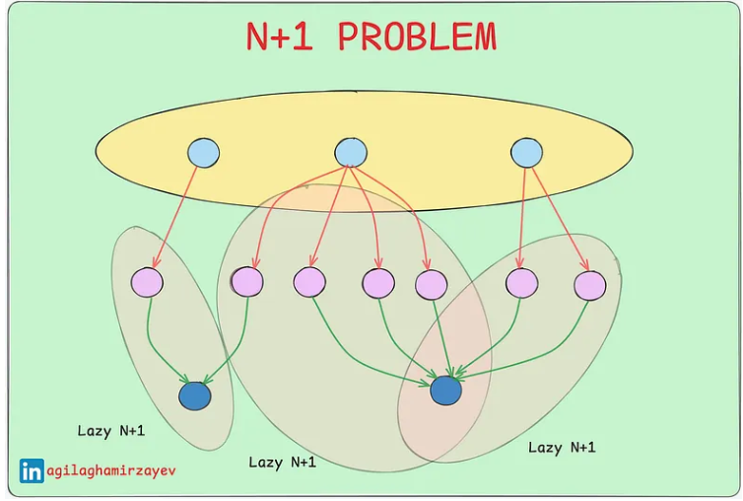

- What is it:
- Imagine you want to fetch a list of 100 orders from your database. But instead of getting all the data in one or two queries, your application runs 101 queries: one to get the list of order IDs, and then one separate query for each order’s details.
- That’s the N+1 problem — 1 query to get N IDs + N queries to get each record.
- Even though each query is small and fast, the combined number of queries slows your app down and puts a heavy load on your database.
- Why It Happens
- This problem usually sneaks in because of incorrect fetch configuration in your ORM (like Hibernate or JPA). Specifically, when using lazy loading:
@OneToMany(fetch = FetchType.LAZY)
private List<LineItem> items;
- The application loads the main object (e.g., Order), but loads each related object (LineItem) only when it’s accessed. So, for 100 orders, you’ll get 100 extra queries — one per LineItem.
- If you switch to eager loading, all the data can be fetched in a single query (or maybe two). But that comes with its risks: too much data, longer queries, and more memory usage.
- When to Use Lazy vs. Eager
- You rarely need related data -> use Lazy
You almost always need it -> user Eager
- How to Detect It
- Your app is slow under high load, but fine with a few users.
- DB monitoring tools show hundreds or thousands of small queries.
- Your logs are flooded with repetitive SQL like SELECT * FROM LineItem WHERE order_id =?
- Just spring.jpa.show-sql=true and check your queries before deploying to prod
- How to Fix or Avoid It
- Understand your data access pattern
Are you usually displaying the full order details? Then eager loading makes more sense.
- Use JOIN FETCH in JPQL or Criteria API
This fetches the main object and its relations in one query
- Use @EntityGraph(“entityName”)
JPA provides the concept of an entity graph, which allows you to define a graph of entities to load eagerly.
- Use DTO projection
By creating a DTO that contains only the necessary information, you can avoid loading unnecessary associations
- Don’t blindly accept defaults
Many ORMs default to lazy loading. That might not be the best option for your use case.

- Problem #2: Skipping the Cache
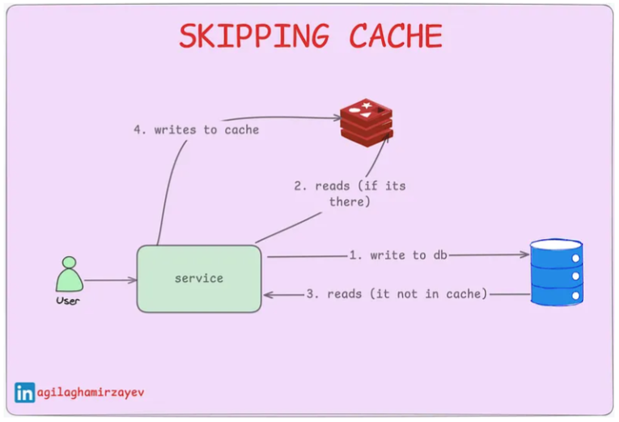

- What’s the issue?
- Hitting the database every time you need data is slow and expensive. Whether it’s over the network or local, database calls add latency and increase load. That’s why smart apps cache frequently-used data — to serve users faster and reduce pressure on the database.

- Common Caching Mistakes
- No cache at all
Every request goes straight to the database. Super slow, especially under load.

- Bad cache configuration
For example, not setting TTL (time-to-live), letting memory bloat, or forgetting to enable L2 cache in Hibernate.
- Distributed cache not in sync
In a multi-server setup, one server might cache one version of the data, and another server might have a different one. This causes inconsistency and weird bugs.

- Symptoms of No/Bad Caching
- DB CPU usage spikes as user load increases
- Response times slow down noticeably
- Lots of repeated SQL queries in logs
- The cache hit ratio is low (less than 70%)

- Fixing and Preventing the Problem
- Add caching early in the design
It’s much easier to add when building than retrofitting later.
- Make your objects serializable
Most caching tools require this to move data between memory/disk/servers.
- Cache smartly — not everything
Cache data that:
- Is read frequently
- Doesn’t change often
- It is expensive to compute or fetch
- Keep it monitored
Set up alerts if your cache hit ratio drops or memory usage spikes.

3. Problem #3: Database connection pools configs
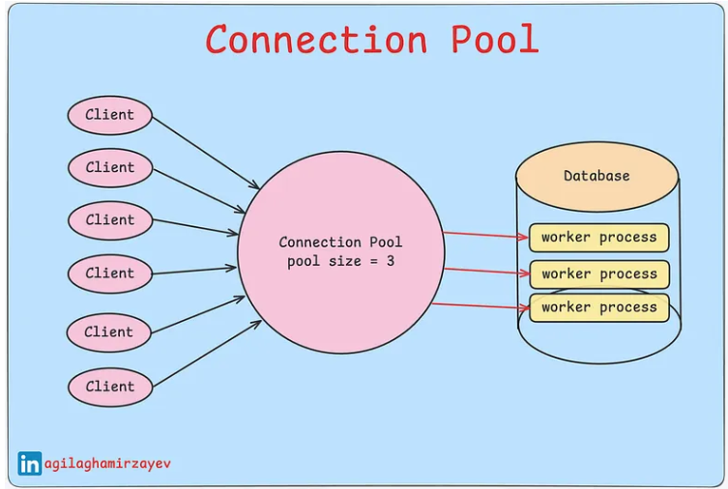
- Understanding Database Connection Pooling
- Imagine you’re at a supermarket with only 2 open checkout lanes and a flood of customers. You wait… and wait. That’s exactly what happens when your application doesn’t have enough database connections available — your users queue up, response times increase, and frustration builds.
- What Is a Connection Pool?
- A connection pool is a set of pre-created database connections that your application can reuse. Creating a DB connection from scratch is expensive, so pooling avoids that cost by keeping connections open and ready to go.
- But there’s a catch:
- Too few connections = slow responses (users wait for a connection)
- Too many connections = DB overload (database chokes under pressure).
Your job? Balance it perfectly.
- Why We Use It
- Connections are expensive to create repeatedly
- DB is a shared resource — pools help manage load
- Controlled usage prevents database overload
- Symptoms to Watch Out For
- The app is slow, but the DB is underused
The pool is too small — threads are waiting for a connection
- The app is slow, and the DB is overused
The pool is too large — DB is being flooded with queries
- Best Practices to Avoid This
- First, Optimize SQL Queries
Bad queries will choke your DB no matter what the pool size is.
- Understand Query Load Balance
Know which queries run most often and adjust accordingly.
- Load Test Your DB
Find out how much traffic it can handle with realistic data and concurrency.
- Tune Pool Size Under Load
Run tests with different connection pool sizes.
➕ Goal: Find the max size just before your DB gets saturated.
- Monitor in Production
Use monitoring tools to keep an eye on:
- Active connections
- Connection wait time
- Query response times

